Silent Rebirth: The Rise of Simon Wheeler

Chapter 1 — The Man Who Had Nothing
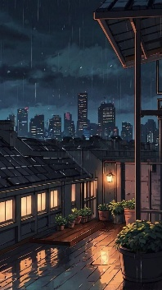
Simon Wheeler was twenty-six years old when his life ended.
No family.
No career.
No dreams left.
He spent most of his days in a tiny apartment in the city, surviving on cheap instant noodles and forgotten ambitions. Every job interview ended the same way:
"We'll contact you later."
But nobody ever did.
At night, Simon escaped reality through fantasy novels and games. Worlds filled with magic, knights, dragons, and heroes. Worlds where even the weakest person could become someone important.
Reality, however, was cruel.
One rainy evening, while returning from another failed interview, Simon saw a little girl standing in the middle of a crossing. A truck was speeding toward her.
People screamed.
Nobody moved.
Except Simon.
He ran forward without thinking and pushed the girl away.
The last thing he heard was the deafening sound of metal.
Then darkness.

Chapter 2 — The God of Rebirth
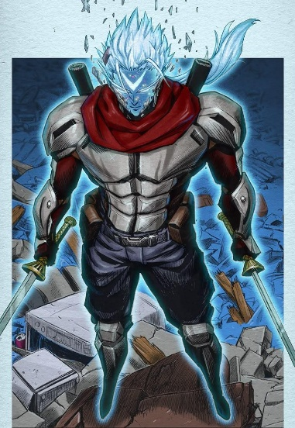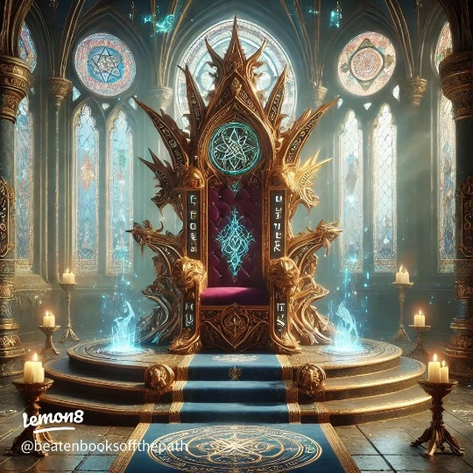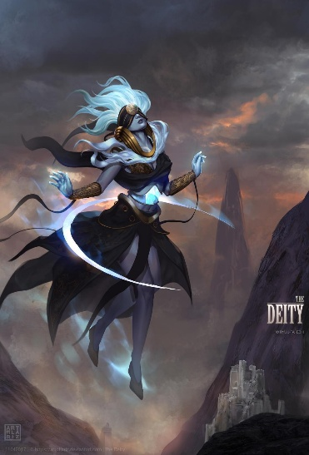
Simon opened his eyes in an endless white space.
Before him sat a towering figure wrapped in silver light.
“I am the Keeper of Worlds,” the being said. “Simon Wheeler… your life was unfortunate, but your final act carried courage.”
Simon laughed bitterly.
“So now what? Heaven?”
“No. Rebirth.”
The god waved a hand, and countless worlds appeared like floating stars.
“One of these worlds is called Eldoria. A land of swords, magic, monsters, and ancient dragons.”
Simon stared silently.
“You shall live again there.”
A glowing screen appeared before him.

Gifts Granted to Simon Wheeler

1. Infinite Adaptation
Any attack, magic, poison, or curse used against him would eventually become useless after experiencing it once.

2. Void Eyes
Eyes capable of seeing mana flow, enemy weaknesses, lies, hidden traps, and future movements for a few seconds.

3. Absolute Dominion
The terrifying ability to overwhelm and suppress all lower beings through pure aura alone.
Simon blinked.
“That sounds overpowered.”
The god smiled.
“It is.”
“And why give that to someone like me?”
“Because even after the world abandoned you… you still chose to save someone.”
The white world shattered into light.

Chapter 3 — The New World
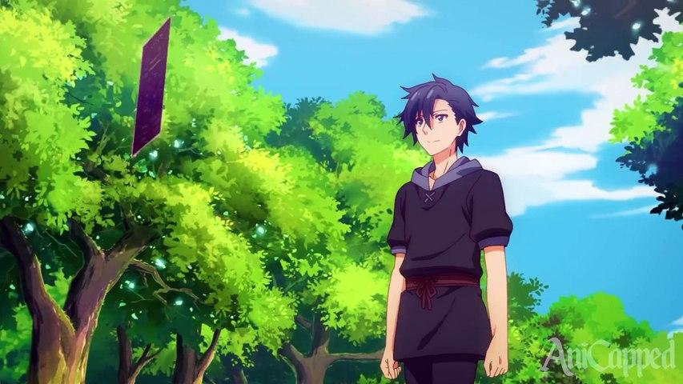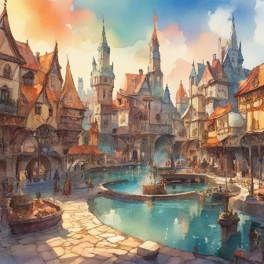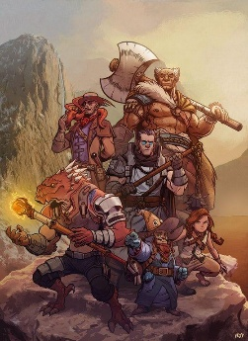
Simon awoke in a forest beneath a blue sky.
Two moons hung above the horizon.
He had truly reincarnated.
Within days, Simon discovered how absurdly powerful he had become.
A wolf monster attacked him.
The moment its claws touched him, his body adapted instantly.
The next claw strike shattered against his skin.
Bandits tried ambushing him later.
Using Void Eyes, Simon saw every movement before it happened.
It felt like time itself slowed down.
And when an arrogant mercenary tried threatening him—
Simon unconsciously released a fragment of Absolute Dominion.
The man collapsed to the ground crying.
After that, Simon understood something important.
If people discovered his true strength, trouble would follow endlessly.
So he hid it.
He dressed like an ordinary traveler and joined a small adventurer group in the city of Valthera.

Chapter 4 — The Silent Adventurer
His new companions slowly became the first real friends Simon ever had.

The Group
- Elena — a talented fire mage with a sharp tongue.
- Gareth — a giant swordsman who laughed too loudly.
- Mira — a quiet healer who noticed everything.
- Finn — an archer who constantly challenged Simon to competitions.
Simon rarely talked about himself.
To everyone else, he seemed weak but strangely calm.
Whenever monsters appeared, he intentionally held back.
Even so, his teammates noticed unusual things.
No poison worked on him.
No ambush ever surprised him.
And somehow… monsters avoided eye contact with him.
One evening around a campfire, Elena asked:
“Simon… who exactly are you?”
Simon stared into the flames.
“Just someone who failed in his previous life.”
Nobody understood what he meant.

Chapter 5 — The Dragon of Black Flame
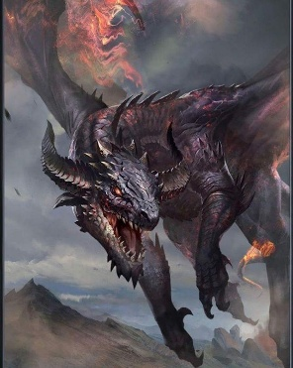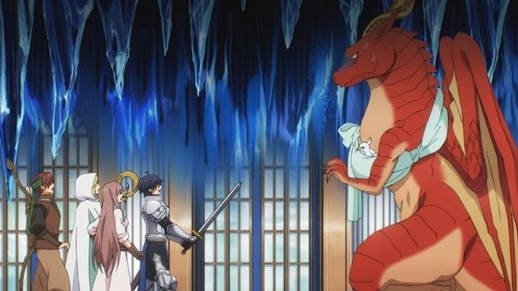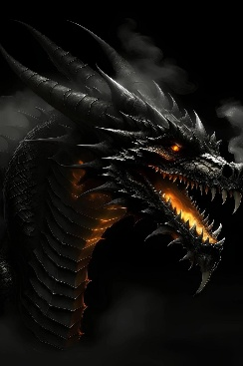
Everything changed three months later.
Simon’s party accepted a simple escort mission near the Ashen Mountains.
But the moment they entered the valley—
The sky turned black.
A monstrous roar shook the earth.
From the clouds descended a dragon larger than a castle.
Black scales.
Golden eyes.
Flames darker than night itself.
The legendary calamity:
The Black Flame Dragon — Nidhoros.
The dragon landed before them, shattering the ground.
Finn froze.
Mira collapsed in fear.
Even Gareth’s sword trembled.
Nidhoros laughed.
“Humans… insignificant insects.”
Black fire exploded across the valley.
Elena screamed as magical barriers shattered instantly.
The party was seconds away from death.
And then—
Simon stepped forward.
For the first time since reincarnating…
His expression changed.
Cold.
Emotionless.
Terrifying.
The dragon narrowed its eyes.
“…What are you?”
Simon spoke quietly.
“Someone who wants a peaceful life.”
Nidhoros unleashed another inferno.
But this time, Simon walked through the flames unharmed.
Infinite Adaptation had already evolved.
The dragon’s fire no longer affected him.
Shock spread across everyone’s faces.
Simon slowly raised his eyes.
The Void Eyes glowed silver.
He could see every weakness within the dragon’s mana flow.
Every scale.
Every movement.
Every future attack.
Nidhoros roared and charged.
The mountains split apart.
But Simon disappeared.
BOOM.
A single punch struck the dragon’s jaw.
The massive creature crashed through an entire cliffside.
Silence filled the valley.
The dragon rose shakily.
Impossible fear appeared in its ancient eyes.
Simon released Absolute Dominion.
The air itself became heavy.
The mountains trembled.
Monsters across the valley fled instantly.
Nidhoros collapsed to its knees.
“A… human… cannot possess such power…”
Simon walked toward the dragon slowly.
“In my previous life, I was powerless.”
His aura intensified.
“But not anymore.”
With one final strike—
The Black Flame Dragon fell.

Chapter 6 — The Beginning of the Legend
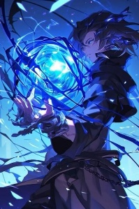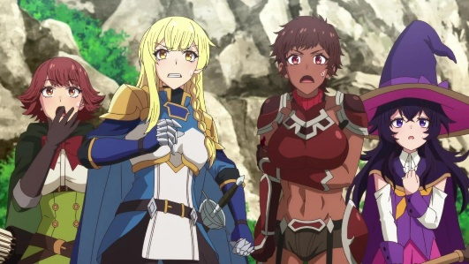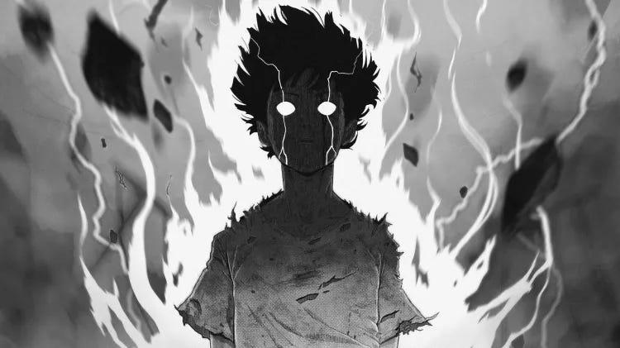
The valley remained silent.
Elena stared at Simon with disbelief.
“You… were hiding THIS the entire time?!”
Simon scratched his head awkwardly.
“…I didn’t want attention.”
Finn shouted, “YOU PUNCHED A DRAGON!”
Even Gareth looked terrified now.
Mira, however, simply smiled softly.
“I knew you were lonely.”
Simon froze.
Nobody had ever understood him so easily before.
Far away, hidden figures watched from the shadows.
Kings.
Demons.
Ancient beings.
All had sensed the battle.
And all reached the same conclusion.
A monster greater than dragons had appeared in Eldoria.
His name was Simon Wheeler.
And the world itself was about to change forever.

